**Connecting Social Media to E-Commerce: Cold-Start Product Recommendation Using Microblogging Information**

**ABSTRACT:**

In recent years, the boundaries between e-commerce and social networking have become increasingly blurred. Many e-commerce websites support the mechanism of social login where users can sign on the websites using their social network identities such as their Facebook or Twitter accounts. Users can also post their newly purchased products on microblogs with links to the e-commerce product web pages. In this paper, we propose a novel solution for cross-site cold-start product recommendation, which aims to recommend products from e-commerce websites to users at social networking sites in “cold-start” situations, a problem which has rarely been explored before. A major challenge is how to leverage knowledge extracted from social networking sites for cross-site cold-start product recommendation. We propose to use the linked users across social networking sites and e-commerce websites (users who have social networking accounts and have made purchases on e-commerce websites) as a bridge to map users’ social networking features to another feature representation for product recommendation. In specific, we propose learning both users’ and products’ feature representations (called user embeddings and product embeddings, respectively) from data collected from e-commerce websites using recurrent neural networks and then apply a modified gradient boosting trees method to transform users’ social networking features into user embeddings. We then develop a feature-based matrix factorization approach which can leverage the learnt user embeddings for cold-start product recommendation. Experimental results on a large dataset constructed from the largest Chinese microblogging service SINA WEIBO and the largest Chinese B2C e-commerce website JINGDONG have shown the effectiveness of our proposed framework.

**EXISTING SYSTEM:**

* Most studies only focus on constructing solutions within certain e-commerce websites and mainly utilise users’ historical transaction records. To the best of our knowledge, cross-site cold-start product recommendation has been rarely studied before.
* There has also been a large body of research work focusing specifically on the cold-start recommendation problem.
* Seroussi et al. proposed to make use of the information from users’ public profiles and topics extracted from user generated content into a matrix factorization model for new users’ rating prediction.
* Zhang et al. propose a semi-supervised ensemble learning algorithm.
* Schein proposed a method by combining content and collaborative data under a single probabilistic framework.
* Lin et al. addressed the cold-start problem for App recommendation by using the social information.

**DISADVANTAGES OF EXISTING SYSTEM:**

* They only focus on brand or category-level purchase preference based on a trained classifier, which cannot be directly applied to our cross-site cold start product recommendation task.
* Their features only include gender, age and Facebook likes, as opposed to a wide range of features explored in our approach.
* They do not consider how to transfer heterogeneous information from social media websites into a form that is ready for use on the e-commerce side, which is the key to address the cross-site cold-start recommendation problem.

**PROPOSED SYSTEM:**

* In this paper, we study an interesting problem of recommending products from e-commerce websites to users at social networking sites who do not have historical purchase records, i.e., in “cold-start” situations. We called this problem cross-site cold-start product recommendation.
* In our problem setting here, only the users’ social networking information is available and it is a challenging task to transform the social networking information into latent user features which can be effectively used for product recommendation. To address this challenge, we propose to use the linked users across social networking sites and e-commerce websites (users who have social networking accounts and have made purchases on e-commerce websites) as a bridge to map users’ social networking features to latent features for product recommendation.
* In specific, we propose learning both users’ and products’ feature representations (called user embeddings and product embeddings, respectively) from data collected from e-commerce websites using recurrent neural networks and then apply a modified gradient boosting trees method to transform users’ social networking features into user embeddings.
* We then develop a feature-based matrix factorization approach which can leverage the learnt user embeddings for cold start product recommendation.

**ADVANTAGES OF PROPOSED SYSTEM:**

* Our proposed framework is indeed effective in addressing the cross-site cold-start product recommendation problem.
* We believe that our study will have profound impact on both research and industry communities.
* We formulate a novel problem of recommending products from an e-commerce website to social networking users in “cold-start” situations.
* To the best of our knowledge, it has been rarely studied before.
* We propose to apply the recurrent neural networks for learning correlated feature representations for both users and products from data collected from an e-commerce website.
* We propose a modified gradient boosting trees method to transform users’ microblogging attributes to latent feature representation which can be easily incorporated for product recommendation.
* We propose and instantiate a feature-based matrix factorization approach by incorporating user and product features for cold-start product recommendation

**SYSTEM ARCHITECTURE:**

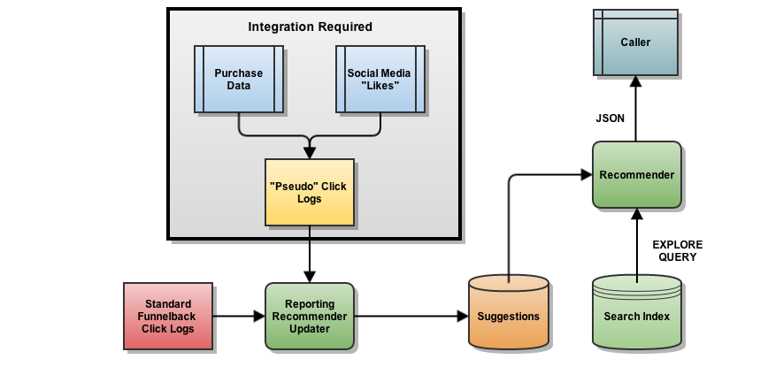

**MODULES:**

* OSN System Construction Module
* Microblogging Feature Selection
* Learning Product Embeddings
* Cold-Start Product Recommendation

**MODULES DESCSRIPTION:**

**OSN System Construction Module**

* In the first module, we develop the Online Social Networking (OSN) system module. We build up the system with the feature of Online Social Networking. Where, this module is used for new user registrations and after registrations the users can login with their authentication.
* Where after the existing users can send messages to privately and publicly, options are built. Users can also share post with others. The user can able to search the other user profiles and public posts. In this module users can also accept and send friend requests.
* With all the basic feature of Online Social Networking System modules is build up in the initial module, to prove and evaluate our system features.
* Given an e-commerce website, with a set of its users, a set of products and purchase record matrix, each entry of which is a binary value indicating whether has purchased product. Each user is associated with a set of purchased products with the purchase timestamps. Furthermore, a small subset of users can be linked to their microblogging accounts (or other social network accounts).

**Microblogging Feature Selection**

* In this module, we develop the Microblogging Feature Selection. Prepare a list of potentially useful microblogging attributes and construct the microblogging feature vector for each linked user. Generate distributed feature representations using the information from all the users on the ecommerce website through deep learning. Learn the mapping function, which transforms the microblogging attribute information au to the distributed feature representations in the second step. It utilises the feature representation pairs of all the linked users as training data.
* Ademographic profile (often shortened as “a demographic”) of a user such as sex, age and education can be used by ecommerce companies to provide better personalised services. We extract users’ demographic attributes from their public profiles. Demographic attributes have been shown to be very important in marketing, especially in product adoption for consumers

**Learning Product Embeddings**

* In the previous module, we develop the feature selection, but it is not straightforward to establish connections between users and products. Intuitively, users and products should be represented in the same feature space so that a user is closer to the products that he/she has purchased compared to those he/she has not. Inspired by the recently proposed methods in learning word embeddings, we propose to learn user embeddings or distributed representation of user in a similar way.
* Given a set of symbol sequences, a fixed-length vector representation for each symbol can be learned in a latent space by exploiting the context information among symbols, in which “similar” symbols will be mapped to nearby positions. If we treat each product ID as a word token, and convert the historical purchase records of a user into a timestamped sequence, we can then use the same methods to learn product embeddings. Unlike matrix factorization, the order of historical purchases from a user can be naturally captured.

**Cold-Start Product Recommendation**

* We used a local host based e-commerce dataset, which contains some user transaction records. Each transaction record consists of a user ID, a product ID and the purchase timestamp. We first group transaction records by user IDs and then obtain a list of purchased products for each user.
* For our methods, an important component is the embedding models, which can be set to two simple architectures, namely CBOW and Skip-gram. We empirically compare the results of our method ColdE using these two architectures, and find that the performance of using Skip-gram is slightly worse than that of using CBOW.

**SYSTEM REQUIREMENTS:**

**HARDWARE REQUIREMENTS:**

* System : Pentium Dual Core.
* Hard Disk : 120 GB.
* Monitor : 15’’ LED
* Input Devices : Keyboard, Mouse
* Ram : 1GB.

**SOFTWARE REQUIREMENTS:**

* Operating system : Windows 7.
* Coding Language : JAVA/J2EE
* Tool : Netbeans 7.2.1
* Database : MYSQL

**REFERENCE:**

Wayne Xin Zhao, Member, IEEE, Sui Li, Yulan He, Edward Y. Chang, Ji-Rong Wen, Senior Member, IEEE, and Xiaoming Li, Senior Member, IEEE, “Connecting Social Media to E-Commerce: Cold-Start Product Recommendation Using Microblogging Information”, **IEEE TRANSACTIONS ON KNOWLEDGE AND DATA ENGINEERING, VOL. 28, NO. 5, MAY 2016.**